[**DITCHING THE CORPORATE LIFE**](https://www.cnbc.com/ditching-the-corporate-life/)

**At 30, he quit Wall Street and founded one of Australia’s leading fast food chains**

**Published Wed, Dec 4 20198:30 PM EST Updated Wed, Dec 4 20198:33 PM EST**

[**Karen Gilchrist**](https://www.cnbc.com/karen-gilchrist/)

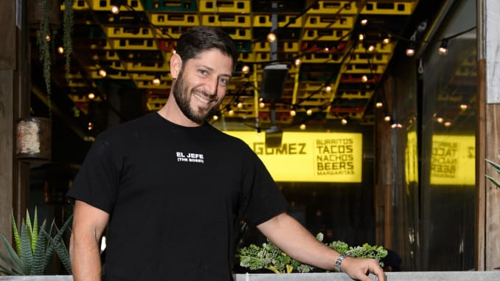

**Guzman Y Gomez’s co-founder and CEO Steven Marks.**

Guzman Y Gomez

SYDNEY — When Steven Marks landed a job at a top Wall Street hedge fund, he thought he had it made.

Marks, then 23-years-old, was one of just two grads in his year to earn a place on legendary [U.S.](https://www.cnbc.com/id/10000385) investor Steve Cohen’s [New York](https://www.cnbc.com/new-york-regional-news/) equities team — a feat for a guy born on the wrong side of the tracks in 1970s Brooklyn.

By 27, he was heading up a London trading desk, enjoying life off Chelsea’s iconic Sloane Square. But, by 30, the sheen had worn off and Marks yearned for a fresh start.

“People think you have to have one career, but that’s just not true,” said Marks.

So, he decided to turn life on its head, and booked a one-way ticket to [Australia](https://www.cnbc.com/australia/) with a dream of starting over.

**FROM FUND MANAGER TO FOUNDER**

Seventeen years on, Marks is the co-founder and CEO of Guzman y Gomez, the Australia-born Mexican casual-dining chain hoping to give the likes of [Chipotle](https://www.cnbc.com/2017/08/16/chipotle-is-doing-some-very-un-chipotle-things-to-win-back-diners.html) a run for its money.

Marks started the business in 2006, a few years after relocating Down Under, and has since expanded to 115 locations across Australia, [Singapore](https://www.cnbc.com/id/10000530) and [Japan](https://www.cnbc.com/japan/).

But, as he told [CNBC Make It](https://www.cnbc.com/make-it/) in [Sydney](https://www.cnbc.com/sydney/), it’s a success story that started quite by accident.

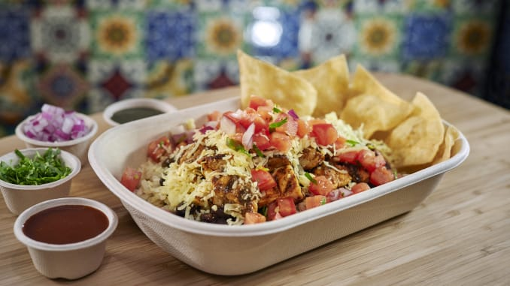

**Guzman Y Gomez’s signature burrito bowl.**

Guzman Y Gomez

“I had these plans to build a hotel by the beach,” recalled Marks. However, while struggling to get his plan off the ground, he stumbled across another idea entirely.

“I really missed good Mexican food,” said Marks, noting he’d been “spoiled” in New York.

“They didn’t know what good Mexican food was in Australia,” he continued. “Most people thought black beans were olives.”

So Marks took it upon himself to show them, investing “everything” he had saved from Wall Street into creating a brand he believed couldn’t fail.

**“The reason you become an entrepreneur is because you think you’re going to do something better.” Steven Marks**

“I poached the best staff from Latin American restaurants and brought in chefs from Mexico,” he said.

It was all part of a determination picked up early in life to do the best job he could, said Marks, who teamed up with Robert Hazan, an old friend from the States, to launch the venture.

“I grew up very entrepreneurial and I knew I didn’t want to just copy somebody else,” Marks said. “The reason you become an entrepreneur is because you think you’re going to do something better.”

**Building a brand**

It wasn’t an easy sell, however, Marks noted.

“We really had to educate the market,” he said, recalling running regular free burrito days to win customers.

But, according to Marks, by doubling down on Sydney and creating locations in “triple A real estate,” he was soon able to establish a strong following.

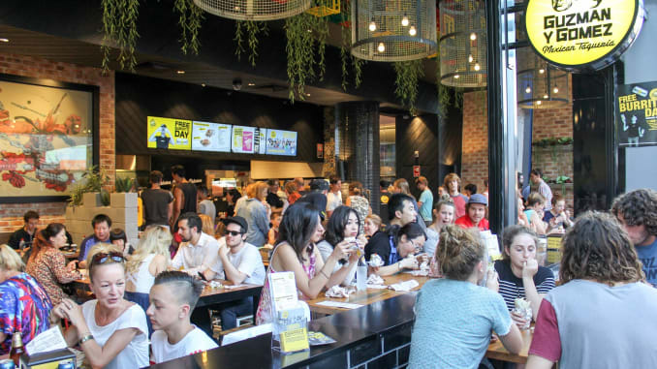

**Guzman Y Gomez’s outlet in Wollongong, Australia.**

Guzman Y Gomez

“I was obsessed with making people love the GyG brand,” said Marks.

“A lot of entrepreneurs make the mistake of going wide and spreading their business too thinly,” he continued. “But I kept things concentrated in Sydney for the first few years.”

**Lessons from Wall Street**

That approach soon caught the eye of investors, who were keen to back the growing GyG brand.

However, Marks said his days on Wall Street had taught him to choose his investors carefully, and rather than take money from people who weren’t aligned with his vision, he opted instead to keep hustling.

“I believe pain is a privilege,” said Marks.

“The people who wanted to invest, I didn’t want them to. So we just had to make it work, even when we were running out of money.”

Three years in, and with six restaurants to their names, Marks’ patience paid off and he and his co-founder struck a deal with the team behind McDonald’s Australia, whom he said shared his passion with and helped fuel the company’s domestic and international expansion.

“I can’t stress more that the board needs to be aligned,” Marks said. “That is so important.”

**A U.S. Homecoming**

A decade on, Marks now has a U.S.-homecoming in mind. GyG is set to open its first North America restaurant in [Chicago](https://www.cnbc.com/id/10000553) in early-2020.

For that, Marks said the brand will be focusing on drive-through locations as it goes head-to-head with major players like Chipotle and Taco Bell.

But the American entrepreneur, who signed a [$44 million deal with investment firm TDM Partners in August 2018](https://www.afr.com/street-talk/tdm-growth-takes-a-bite-of-guzman-y-gomez-20180813-h13vn5) to help with that expansion, said he believes GyG has what it takes to win round a new market all over again.

“When you build something, people are usually too worried about competition,” said Marks.

“I’m not,” he continued. “I know what I’m good at and that’s what I focus on.”

Available at:

<https://www.cnbc.com/2019/12/05/how-guzman-y-gomez-ceo-steven-marks-quit-wall-street-for-mexican-food.html>

**EXERCISES**

1. Encontre, entre as palavras destacadas no texto, os equivalentes para a palavras abaixo:
2. a diretoria = a board
3. abastecer = to fuel
4. abordagem = approaching
5. ansiava = yearned
6. apressado = rushed
7. brilho = sheen
8. caçar furtivamente, “roubar” = to poach
9. capital próprio = equities
10. encabeçar, liderar = heading up
11. estavam interessados em = were keen to
12. ficando sem = running out of
13. fundar = found
14. graduados, formados = grads
15. investimentos alternativos = hedge fund
16. lembrar, chamar à memória = recall
17. mais do que = rather than
18. mimado = spoiled
19. rede (de lojas ou restaurantes) = chain
20. regresso, volta para casa = home coming
21. risco (financeiro) = venture
22. “tropeçar em”, “dar de cara com” = stumbled across
23. um tanto = quite
24. Faça a corrrspondência entre as expressões usadas no texto:
25. a feat for a guy born on the wrong side of the tracks in 1970s Brooklyn.
26. he decided to turn life on its head
27. to give the likes of [Chipotle](https://www.cnbc.com/2017/08/16/chipotle-is-doing-some-very-un-chipotle-things-to-win-back-diners.html) a run for its money.
28. while struggling to get his plan off the ground
29. “triple A real estate”
30. going wide and spreading their business too thinly

( 6 ) ampliando e expandindo seus negócios demais, abrindo demais o leque de produtos oferecidos

( 3 ) dar dinheiro pelos like da Chipotle.

( 2 ) ele resolveu mudar sua vida completamente.

( 4 ) enquanto lutava para fazer seu projeto decolar

( 5 ) um imóvel de classe, chique e bem localizado

( 1 ) uma proeza para um cara que veio de baixo, de uma comunidade.

“Eu sei no que sou bom e é nisso que tenho que focar.”